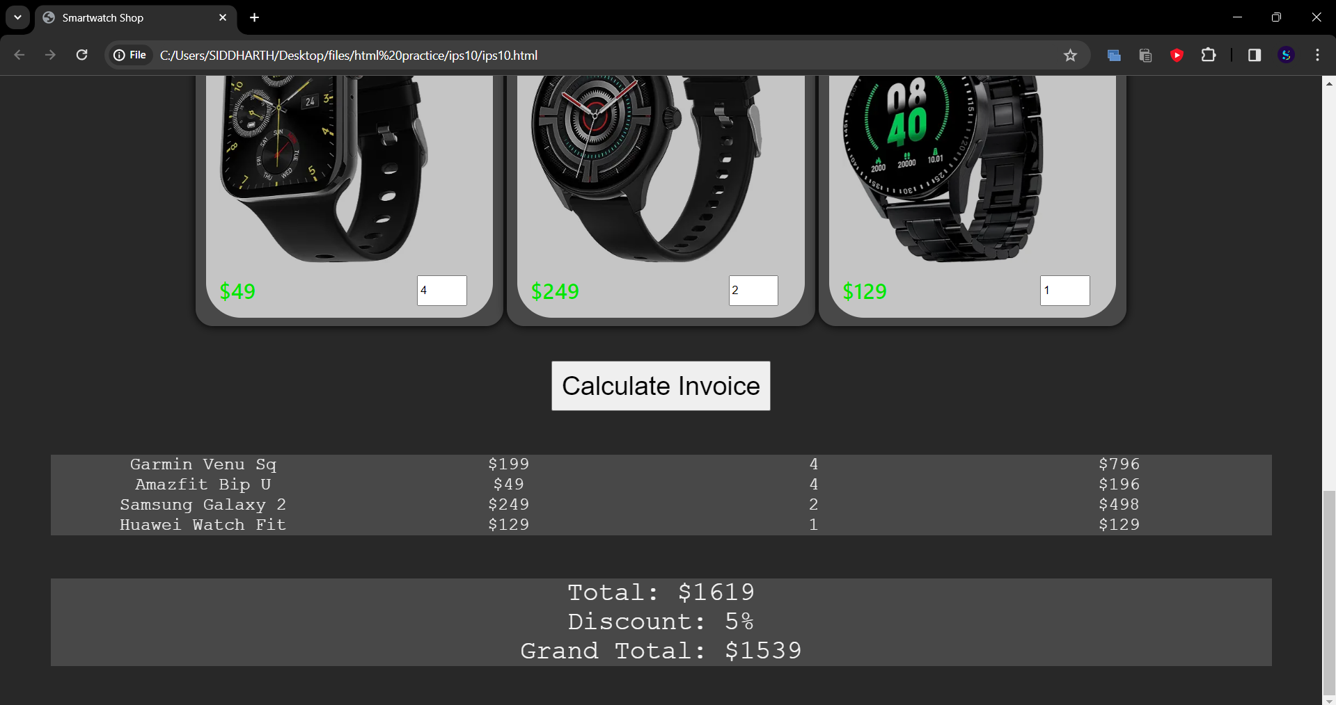

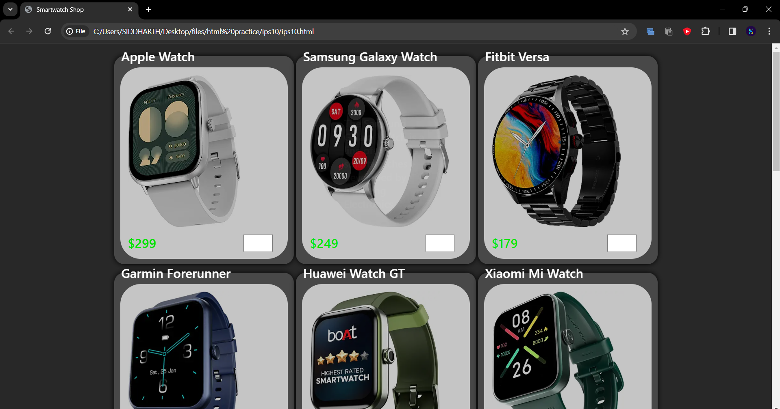

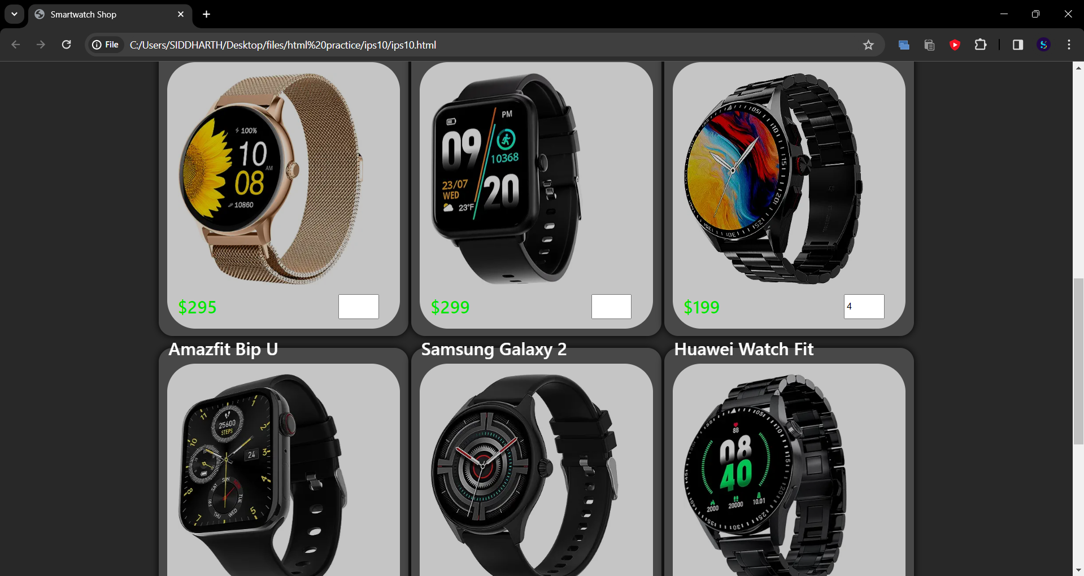

Code:

<!DOCTYPE html>

<html>

<head>

<title>Smartwatch Shop</title>

<style>

body{

background : rgb(40, 40, 40);

font-weight : 500;

font-family :'Segoe UI', Tahoma, Geneva, Verdana, sans-serif

}

.prod-name {

font-size: 25px;

color : white;

}

.prod-cost {

font-size: 25px;

color: rgb(0, 228, 0);

}

.product img {

margin-bottom: 10px;

}

.prod-tool-tip {

position: absolute;

left: 50%;

top: 50%;

transform: translate(-50%, -50%);

color: white;

font-size: 20px;

transition: 0.3s;

opacity: 0;

}

.product {

display: inline-block;

position: relative;

border: 0px solid red;

background : rgb(197, 197, 197);

width : 300px;

padding: 15px;

border-radius: 40px;

}

.product input {

width: 50px;

height: 30px;

position: absolute;

right: 30px;

}

.product img {

transition: 0.3s;

mix-blend-mode: multiply;

}

.product:hover .prod-tool-tip {

opacity: 1;

}

.product:hover img {

filter: blur(2px);

}

.products-main {

display : flex;

flex-direction : column;

}

.prod-row{

display : flex;

justify-content: center;

border : 0px solid yellow;

}

.Products {

display : inline-block;

background : rgb(72, 72, 72);

border: 0px solid blue;

box-shadow : 0 0 10px black;

border-radius : 20px;

}

.sub-btn{

display : flex;

justify-content: center;

margin : 40px 0;

}

.sub-btn button{

font-size : 30px;

padding : 10px;

}

.sub-btn button:hover{

cursor:pointer;

}

#invoice{

font-family:'Courier New';

margin : 50px 50px;

display : grid;

text-align: center;

grid-template-columns: repeat(4,1fr);

grid-template-rows: repeat(3,1fr);

font-size : 20px;

background : rgb(72, 72, 72);

color : whitesmoke;

}

#invoice-final{

font-family:'Courier New';

font-size : 30px;

background : rgb(72, 72, 72);

color : whitesmoke;

margin : 50px;

display : flex;

flex-direction : row;

justify-content: space-evenly;

text-align : center;

}

</style>

</head>

<body>

<div class="products-main">

<div class = "prod-row">

<fieldset class="Products">

<legend class="prod-name">Apple Watch</legend>

<div class="product" id="product">

<img src="1.webp" height = "300px"><br>

<label class="prod-cost">$299</label>

<input type="number" class="quan" id="quan" min = 0>

<div class="prod-tool-tip">

The Apple Watch is a smartwatch developed by Apple Inc.

</div>

</div>

</fieldset>

<fieldset class="Products">

<legend class="prod-name">Samsung Galaxy Watch</legend>

<div class="product" id="product">

<img src="2.webp" height="300px"><br>

<label class="prod-cost">$249</label>

<input type="number" class="quan" id="quan" min = 0>

<div class="prod-tool-tip">

The Samsung Galaxy Watch is a line of smartwatches developed by Samsung Electronics.

</div>

</div>

</fieldset>

<fieldset class="Products">

<legend class="prod-name">Fitbit Versa</legend>

<div class="product" id="product">

<img src="3.webp" height="300px"><br>

<label class="prod-cost">$179</label>

<input type="number" class="quan" id="quan" min = 0>

<div class="prod-tool-tip">

The Fitbit Versa is a smartwatch developed by Fitbit Inc.

</div>

</div>

</fieldset>

</div>

<div class="prod-row">

<fieldset class="Products">

<legend class="prod-name">Garmin Forerunner</legend>

<div class="product" id="product">

<img src="4.webp" height="300px"><br>

<label class="prod-cost">$199</label>

<input type="number" class="quan" id="quan" min = 0>

<div class="prod-tool-tip">

The Garmin Forerunner is a series of smartwatches developed by Garmin Ltd.

</div>

</div>

</fieldset>

<fieldset class="Products">

<legend class="prod-name">Huawei Watch GT</legend>

<div class="product" id="product">

<img src="5.webp" height="300px"><br>

<label class="prod-cost">$229</label>

<input type="number" class="quan" id="quan" min = 0>

<div class="prod-tool-tip">

The Huawei Watch GT is a smartwatch developed by Huawei Technologies Co., Ltd.

</div>

</div>

</fieldset>

<fieldset class="Products">

<legend class="prod-name">Xiaomi Mi Watch</legend>

<div class="product" id="product">

<img src="6.webp" height="300px"><br>

<label class="prod-cost">$129</label>

<input type="number" class="quan" id="quan" min = 0>

<div class="prod-tool-tip">

The Xiaomi Mi Watch is a smartwatch developed by Xiaomi Corporation.

</div>

</div>

</fieldset>

</div>

<div class="prod-row">

<fieldset class="Products">

<legend class="prod-name">Fossil Gen 5</legend>

<div class="product" id="product">

<img src="7.webp" height="300px"><br>

<label class="prod-cost">$295</label>

<input type="number" class="quan" id="quan" min = 0>

<div class="prod-tool-tip">

The Fossil Gen 5 is a smartwatch developed by Fossil Group.

</div>

</div>

</fieldset>

<fieldset class="Products">

<legend class="prod-name">TicWatch Pro 3</legend>

<div class="product" id="product">

<img src="8.webp" height="300px"><br>

<label class="prod-cost">$299</label>

<input type="number" class="quan" id="quan" min = 0>

<div class="prod-tool-tip">

The TicWatch Pro 3 is a smartwatch developed by Mobvoi.

</div>

</div>

</fieldset>

<fieldset class="Products">

<legend class="prod-name">Garmin Venu Sq</legend>

<div class="product" id="product">

<img src="9.webp" height="300px"><br>

<label class="prod-cost">$199</label>

<input type="number" class="quan" id="quan" min = 0>

<div class="prod-tool-tip">

The Garmin Venu Sq is a smartwatch developed by Garmin Ltd.

</div>

</div>

</fieldset>

</div>

<div class="prod-row">

<fieldset class="Products">

<legend class="prod-name">Amazfit Bip U</legend>

<div class="product" id="product">

<img src="10.webp" height="300px"><br>

<label class="prod-cost">$49</label>

<input type="number" class="quan" id="quan" min = 0>

<div class="prod-tool-tip">

The Amazfit Bip U is a smartwatch developed by Huami.

</div>

</div>

</fieldset>

<fieldset class="Products">

<legend class="prod-name">Samsung Galaxy 2</legend>

<div class="product" id="product">

<img src="11.webp" height="300px"><br>

<label class="prod-cost">$249</label>

<input type="number" class="quan" id="quan" min = 0>

<div class="prod-tool-tip">

The Samsung Galaxy Watch Active 2 is a smartwatch developed by Samsung Electronics.

</div>

</div>

</fieldset>

<fieldset class="Products">

<legend class="prod-name">Huawei Watch Fit</legend>

<div class="product" id="product">

<img src="12.webp" height="300px"><br>

<label class="prod-cost">$129</label>

<input type="number" class="quan" id="quan" min = 0>

<div class="prod-tool-tip">

The Huawei Watch Fit is a smartwatch developed by Huawei Technologies Co., Ltd.

</div>

</div>

</fieldset>

</div>

</div>

<div class = "sub-btn">

<button onclick = "calculate_invoice()">Calculate Invoice</button>

</div>

<div id = "invoice">

</div>

<div id = "invoice-final">

</div>

<script>

function calculate_invoice(){

event.preventDefault();

var count = 0;

var bill = 0;

const invoice = document.getElementById('invoice');

const products = document.getElementsByClassName('Products');

console.log(products);

for(p of products) {

var product = p.children[1];

var cost = parseInt(product.children[2].innerHTML.slice(1));

var quan = product.children[3].value;

if(!quan == "" | !quan == 0){

console.log(quan);

quan = parseInt(quan);

count++;

invoice.innerHTML += "<div>"+p.children[0].innerHTML + "</div><div>" +

product.children[2].innerHTML +"</div><div>" +

product.children[3].value + "</div><div>$" +

quan*cost + "</div>";

bill += (cost*quan);

}

};

var discount = 0;

if (count >= 3){discount= 5;}

else if(count >= 7){discount = 10;}

else if(discount >= 10){discount = 15;}

console.log(bill);

const invoice_final = document.getElementById('invoice-final');

invoice_final.innerHTML = "Total: $"+bill + "<br>";

invoice_final.innerHTML += "Discount: "+discount+"%<br>";

invoice_final.innerHTML += "Grand Total: $"+Math.ceil(bill*(1- discount*0.01));

}

</script>

</body>

</html>